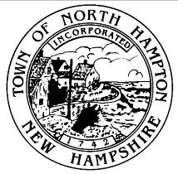

TOWN OF NORTH HAMPTON
the fifth municipal facilities committee

regular meeting – 08 july 2015 – 6:30 p.m.
mary herbert conference room
NORTH HAMPTON Town offices
233 aTLANTIC aVENUE
nORTH hAMPTON, nEW hAMPSHIRE

Purpose: This is the regular meeting of the Municipal Facilities Committee.

- The Call to Order by the Chair

- Old Business: Discuss Fire Department inspection results and document review

- New Business:

  - Discussion with Ron Lamarre of Lavallee Brensinger regarding work plan;
  - Discussion regarding Temporary Fire Department Requirements;
  - Discussion regarding Schedule;
  - Proposed Meeting with Library Trustees

- Approve minutes from July 1, 2015 meeting

- Any other item that may legally come before the Committee

- Adjournment

